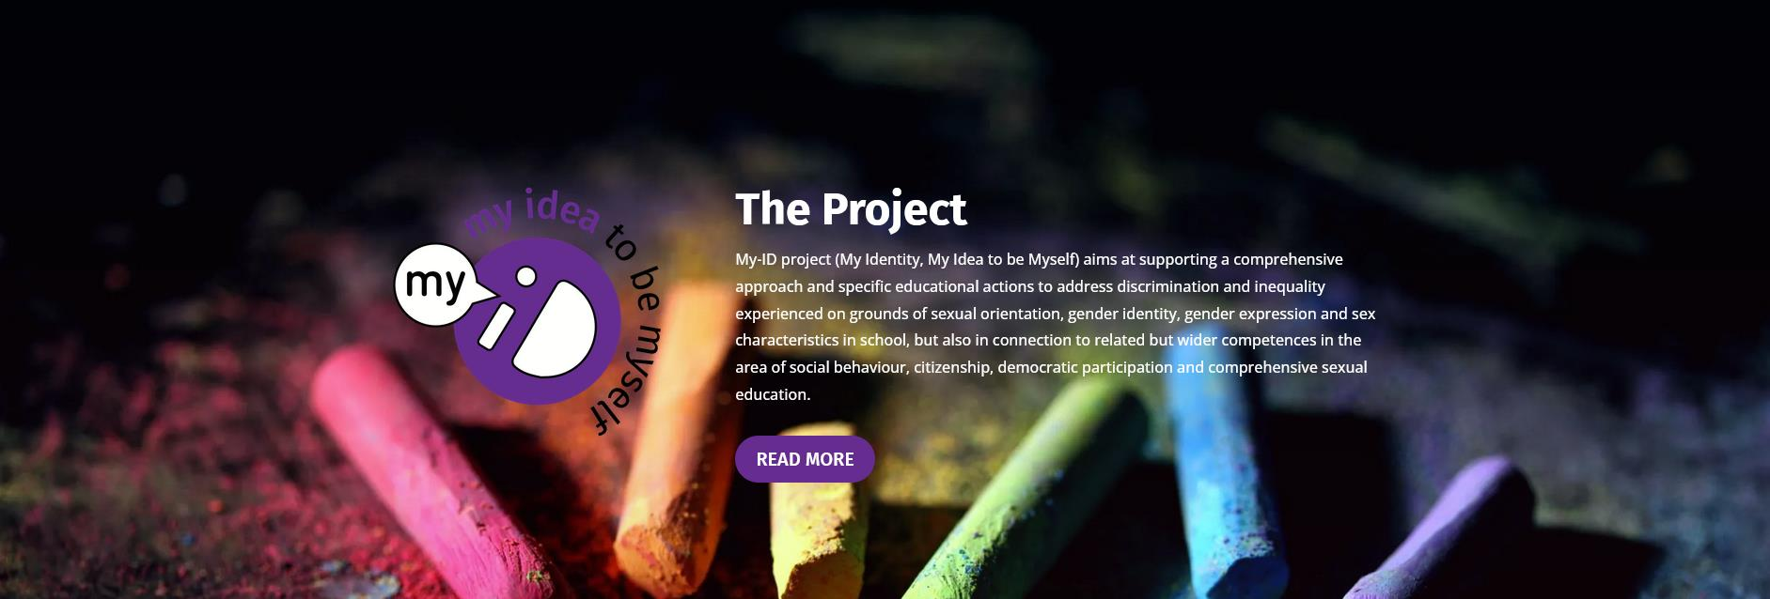

My Identity,
my idea of being myself
In 2021, the My ID (My identity, my idea of being myself) project started in four countries: the Netherlands, Spain, Italy and Greece. The project promotes support for sexual and gender diversity in secondary schools.
The Iedersland College and GALE are organizing a final mini-conference on November 16 from 3:30 PM to 5:30 PM at the Iedersland College (Zekeringstraat 38-40, 1014 BT Amsterdam).
The project partners have written and tested working methods for the classroom, developed and provided flexible teacher training and created tools to inform and involve (conservative) parents.

What is My ID?
GALE and its former Dutch partner EduDivers have developed the My-ID approach to meet the bottlenecks that schools see in tackling the sometimes controversial themes of sexual and gender diversity.
The My-ID approach promotes broad tolerance by increasing the emotional intelligence of students (and teachers). How do you deal with things that are new or that you find strange? How do you discover your true own opinion and how do you deal with different opinions of others? How do you deal with aspects of your culture and faith that are sometimes at odds with what your friends or parents think? These are questions that are not only relevant to sexual and gender diversity, but relate to many more exciting themes.
The My-ID approach teaches teachers and students to deal with the sometimes intense emotions that arise around polarized themes. The My-ID approach seeks a balance between learning a general democratic attitude in combination with LGBTIQ+ specific aspects, and between careful dialogue and more challenging learning assignments that increase emotional flexibility.

Program
3:00 PM Walk-in
15:30 Welcome by Daan van Hooff (director Iedersland College)
15:35 Framework and context: analysis of Dutch policy by Peter Dankmeijer (GALE)
15:45 A look back at the experiences of the My-ID project team at Iedersland College
15:55 Feedback by Ursula Prinsen (project leader of the Incentive Scheme for Healthy Relationships and Sexuality at the School & Safety Foundation and former project leader of School's Out Nijmegen)
4:05 PM Questions and feedback from the audience
4:15 PM BREAK
4:30 PM Round tables
17:15 Plenary closing with short impressions from round tables
5:30 PM Drinks and snacks offered by students
6:00 PM Closing

TO REGISTER:
https://www.gale.info/ November 16, 2023

The round tables
1.EFFECTIVE? - How can we teach 'respect' to students who have great difficulty with sexual and gender diversity? (After all, the core objectives state that students must learn 'respect' for sexual diversity.)
2.WHAT DO THE STUDENTS THINK? - What do students actually think about this? In conversation with students with different cultural backgrounds from Iedersland College.
3. MORE THAN A LESSON - How can secondary schools ensure that there is a continuous learning path (including within citizenship) that promotes (LGBTIQ+) inclusive friendliness?
4.PARENTS WITH DIFFICULTY - How does a school deal with parents who have great difficulty with sexual and gender diversity? Iedersland College has a very multicultural population and has gained experience with this.
5.ACTION SHYNESS - What do teachers need to help build tolerance and support for sexual and gender diversity among students?
6. AROUND THE SCHOOL - How can organizations (education, youth work, municipality, etc.) strengthen the schools and each other on this theme? Walk in
15:
4:05 PM Questions and feedback from the audience
4:15 PM BREAK
4:30 PM Round tables
17:15 Plenary closing with short impressions from round tables
5:30 PM Drinks and snacks
6:00 PM Closing
TO REGISTER:
https://www.gale.info/
November 16, 2023
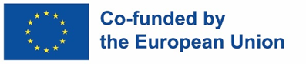
Co-funded by the European Union. Views and opinions expressed are however those of the author(s) only and do not necessarily reflect those of the European Union or the European Education and Culture Executive Agency (EACEA). Neither the European Union nor EACEA can be held responsible for them.

