 |  |  | EVOLVE | 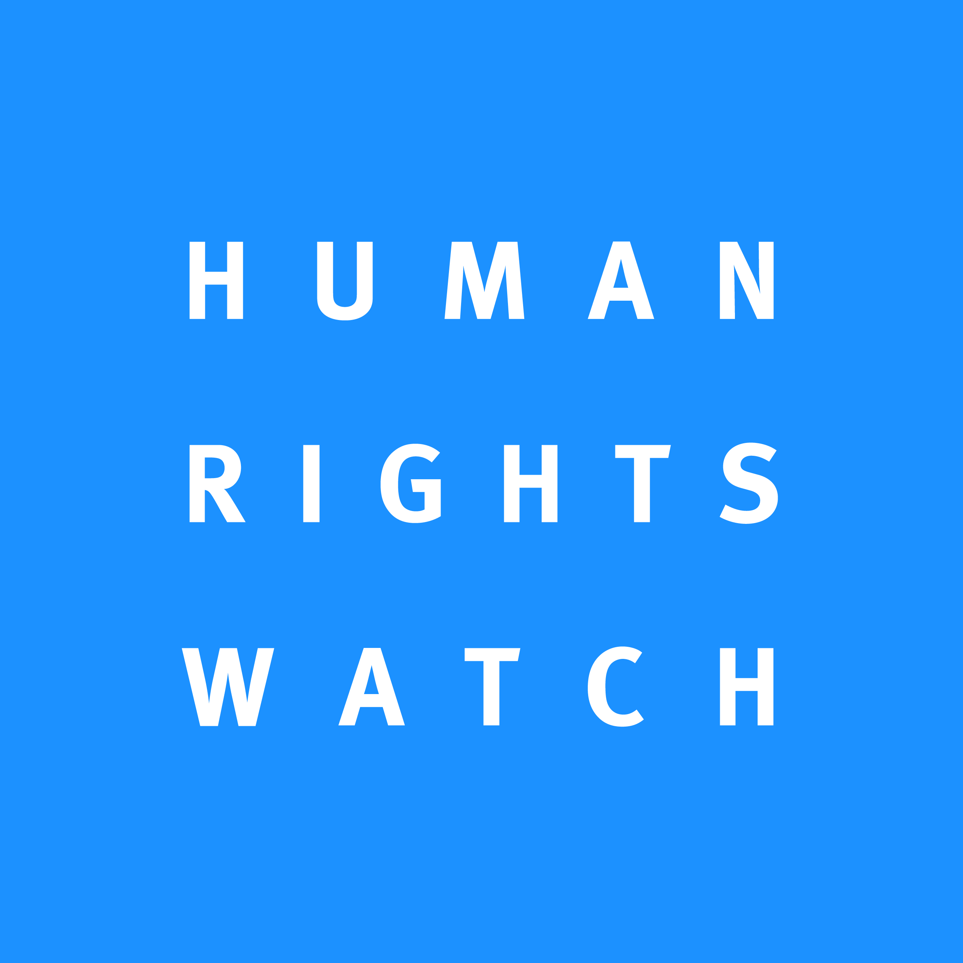

Cameroonian Foundation for AIDS (CAM-FAIDS) | 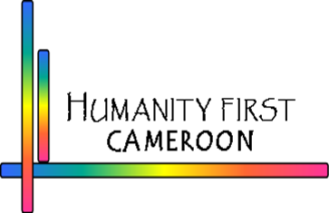 | 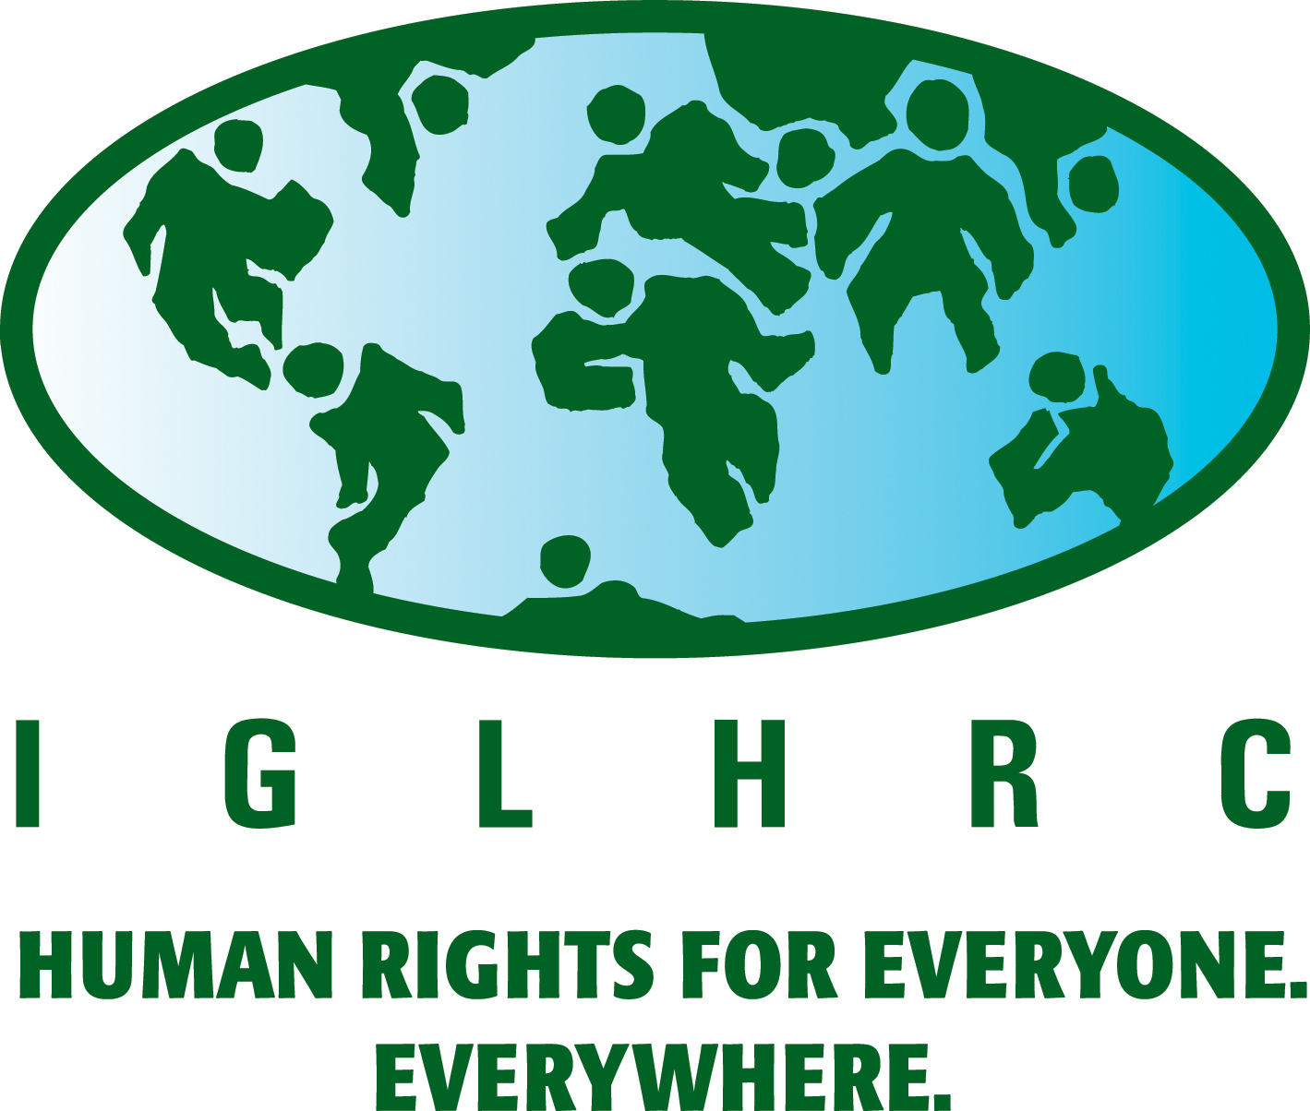

UPR Submission

Cameroon

October 2012

I. Summary

This submission, by Affirmative Action, Alternatives-Cameroun, the Association for the Defense of Gay and Lesbian Rights (ADEFHO), Cameroonian Foundation for AIDS (CAMFAIDS), Evolve, Human Rights Watch, Humanity First Cameroon, and the International Gay and Lesbian Human Rights Commission (IGLHRC), highlights shortcomings in Cameroon’s human rights record related to its treatment of lesbian, gay, bisexual, and transgender people. It is based on research conducted in Cameroon in 2009 and 2010 by ADEFHO, Alternatives-Cameroun, Human Rights Watch, and IGLHRC and published in our 2010 report Criminalizing Identities: Rights Abuses in Cameroon based on Sexual Orientation and Gender Identity, and on follow-up investigations conducted between 2010 and 2012.
Cameroon is one of a handful of countries that regularly prosecutes individuals for consensual same-sex conduct. Article 347 bis of the Cameroon Penal Code punishes “sexual relations with a person of the same sex” with a prison term of six months to five years and with a fine of 20,000 to 200,000 CFA francs (US $40 to $400). There are currently at least two people in prison in Cameron who have been convicted of consensual same-sex conduct and at least three people in prison awaiting trial on the same charges. Others have been released on bail but have ongoing cases against them.
Human rights violations targeting lesbian, gay, bisexual, and transgender (LGBT) people in Cameroon extend beyond the threat of criminal prosecution. Police abuse against LGBT people is rife, with documented cases of police beatings that rise to the level of torture. LGBT people are also vulnerable to violence by community members. In such cases, they are often unable to seek justice due to fear of being treated as criminals themselves.
Organizations supporting LGBT rights in Cameroon are at risk. In February 2012, police in Douala arrested a young man, accused him of homosexuality, and made him denounce the organization Alternatives-Cameroun on television in exchange for his release, forcing the organization to suspend its activities due to hostility from the public. In March 2012, authorities in Yaoundé illegally shut down a workshop on the rights of sexual and gender minorities, in violation of the rights to freedom of association and expression. Several months later, also in Yaoundé, a mob violently attacked a gathering in celebration of the International Day against Homophobia, organized by groups that provide services to LGBT people.
Cameroon has taken insufficient measures to uphold the right to health for LGBT people. Although its National Strategic Framework on HIV, AIDS, and STIs recognizes the need to reach key populations such as men who have sex with men (MSM), Cameroon does not currently have HIV programs targeting their particular needs. Further, the existence of the law perpetuates stigma and drives LGBT people underground, making them less likely to seek out treatment and prevention services.
Alternatives-Cameroun petitioned the National Assembly for decriminalization in November 2009, but the National Assembly has not even considered introducing the topic into discussion. During the previous UPR in 2008, Cameroon rejected a number of recommendations to amend the Penal Code with the view to decriminalize consensual same-sex conduct. However, such recommendations should be reiterated in the context of the 2012 UPR given that Cameroon’s unwillingness to eliminate homosexual acts from its Penal Code contradicts its own domestic law, which mandates that “provisions of criminal law shall be subject to the rules of international law and to all treaties duly promulgated and published.” Moreover, additional steps should be recommended to the government of Cameroon to improve the protection of lesbian, gay, bisexual, and transgender people in the country.
II. Legal Environment
Article 347 bis, the law prohibiting consensual same-sex conduct, was entered into law by presidential ordinance in 1972 without the usual review by the National Assembly. The law thus violates Cameroon’s 1996 constitution.
ADEFHO has documented at least 51 arrests and prosecutions of LGBT people or those suspected of being gay or lesbian since 2005. At least five people are currently in Cameroonian prisons on the basis of article 347 bis, with two serving out sentences on charges of consensual same-sex conduct, at least three in pre-trial detention. At least four others have cases pending against them but are free on bail. Arrests since 2008 include the following:
- In March 2010, Stéphane Maliedji, Jacques Yenguie, and John Vaseck (an Australian citizen), were arrested and jailed for three days after police arrested them in a hotel lobby in Douala on suspicion of homosexuality.
- In September 2010, Roger Bruno Efaaba Efaaba and Marc Henri Bata were arrested in Yaoundé and held in pre-trial detention after police found them in possession of condoms and lubricant labeled “glisse entre mecs” (“slide between guys”). They were convicted of homosexuality in March 2011 and sentenced to six months in prison and then released for time served.
- In March 2011, Jean-Claude Roger Mbede was arrested and subsequently convicted after writing a romantic text message to another man. He was released provisionally in July 2012 due to health reasons, but faces the risk of being returned to prison. His conviction is currently under appeal.
- In July 2011, Jonas Singa Kumie and Franky Djome were arrested for homosexual conduct; they were sentenced in November 2011 to five years in prison. Both men are currently appealing their convictions. A third man, arrested with them but provisionally released, was convicted in absentia.
- In August 2011, Joseph Magloire Ombwa was arrested at his home. Subsequently, Sylvain Séraphin Ntsama, and Emma Loutsi Tiomela (a child of 17 years) were arrested when visiting Ombwa at a police station in Yaoundé, and Nicolas Ntamack was arrested at the home of Ntsama. Ombwa was subjected to an anal examination by a military medical doctor. Emma Loutsi Tiomela and Nicolas Ntamack were provisionally released in July 2012, while Ombwa and Ntsama remain in prison pending trial.
- In August 2011, Stéphane Nounga and a man known as Eric O. were detained in Yaoundé, and subsequently released, when a man asked to meet them after chatting on the internet and then turned them in to the police.
- In September 2011, a man was detained for two days in Douala after the parents of another man asked gendarmes to arrest him for allegedly seeking contact with their son.
- In February 2012, two women, Aboa Esther and Abessolo Martine Solange, were arrested in Ambam and charged with lesbianism. The two women were released on condition that they appear of their own accord before the Court after the intervention of a lawyer, who introduced a motion at the Southern Appeal Court to have the proceedings annulled/void. They are awaiting the court’s decision.
- In June 2012, Samuel Gervais Akam was arrested in Douala after police allegedly discovered images of Akam engaged in homosexual conduct on his personal laptop. He is currently in prison awaiting trial.
The United Nations Human Rights Committee, in Toonen v. Australia (1994), ruled that the criminalization of consensual same-sex conduct violates the International Covenant on Civil and Political Rights, specifically, the right to privacy and the right to non-discrimination. According to the UN Working Group on Arbitrary Detention, arrests on the basis of sexual orientation are, by definition, human rights violations.
In some cases, Cameroonian authorities conduct anal examinations of those suspected of homosexuality. This procedure has no scientific value in determining whether consensual anal penetration has occurred. Such practices violate the Convention against Torture and Other Cruel, Inhuman or Degrading Treatment or Punishment.
The government of Cameroon should:
- Decriminalize consensual same-sex conduct, striking article 347 bis from the Penal Code.
- Release all prisoners who are currently detained on the basis of sexual orientation.
- Until article 347 bis is repealed, instruct the Ministry of Justice to issue a directive to the general prosecutor to cease arrests and prosecutions under the article.
- Ban the practice of anal examinations to prove a history of homosexual conduct.
III. Police Conduct and Violations of Criminal Procedure
The organizations have documented cases of abuse of detainees accused of consensual same-sex conduct by police and gendarmes, including the following:
- In early 2009, police beat a gay man in Muyuka, who had been turned in by a man he had made a date with, in order to extract a confession of homosexuality.
- In March 2009, a man accused of homosexuality was stripped of his clothing and detained in Douala for a week, during which a police officer allegedly beat him repeatedly with a baton.
- In October 2009, police in Douala beat and kicked a man in custody in order to to get him to confess to homosexuality.
- In August and September 2011, on at least three occasions, a scam artist in Yaoundé posed as gay on social media sites in order to make dates with gay men. He then turned them in to the police or the gendarmerie. In two cases, the victims were forced to pay bribes, which were shared between the security forces and the scam artist.
The police also acted wrongfully in shutting down a human rights workshop for LGBT people in Yaoundé in March 2012, discussed further below.
Police also violate Cameroon’s own Code of Criminal Procedure in the manner in which they arrest persons suspected of homosexuality. Article 347 bis only applies to individuals caught in the act of same-sex sexual conduct, but most of the persons on this list were arrested on the basis of mere suspicion; often without arrest warrants; and at all times of day and night, rather than during the hours in which arrest warrants can legally be enforced. Despite the fact that human rights violations occur during arrests or pretrial detention, many people arrested for homosexuality are prosecuted and convicted.

The government of Cameroon should:
- Direct the Ministry of Interior to issue clear and public instructions that police violence against people on the basis of sexual orientation or gender identity will not be tolerated.
- Ensure that the Ministry of Interior introduces sensitivity and human rights training on sexual orientation and gender identity for police at all levels.
- Ensure that the general prosecutor investigates and prosecutes police who commit human rights abuses against LGBT people and other detainees.
- Establish an independent police oversight mechanism to allow civilians to file complaints against the police without fear of retribution.
- Direct the police to respect the Code of Criminal Procedure in carrying out arrests.
IV. Access to Justice
LGBT people who are victims of crime in Cameroon can be denied justice on the basis of their sexual orientation or gender identity. When they are victims of crime, they may be reluctant to seek justice or police protection, or may be turned away when they do so.
The organizations documented a 2009 case of a man who was attacked and robbed by thugs. When police arrived, the attackers said he was homosexual. Police released the attackers and detained the victim for a week. In January 2011, police in Bonaberi failed to investigate the case of a gay man who was publicly beaten on the street.
Alternatives-Cameroun, CAMFAIDS, and other human rights organizations based in Cameroon have found that many gay men and lesbians in Yaoundé and Douala have been subjected to blackmail by persons seeking to exploit their vulnerability under Cameroonian law.
The government of Cameroon should:
- Direct the general prosecutor to issue instructions to the police to investigate alleged crimes directed against LGBT persons, without using the complaint as the basis to initiate proceedings against the complainant on grounds of article 347 bis.
V. Equitable Access to the Highest Attainable Standard to Health
The criminalization of consensual same-sex conduct has nefarious health consequences for sexual and gender minorities. Studies demonstrate that laws criminalizing same-sex intimacy pose barriers to HIV prevention, care, and treatment services.
UNAIDS has found that health centers in Cameroon have turned away clients on the basis of their presumed sexual orientation. Sexual minorities are often afraid to seek services, for fear of their sexual orientation being exposed.
Men who have sex with men (MSM) are not adequately reached by current government prevention programs. Cameroon’s National AIDS Control Committee conducted its first study of HIV prevalence rates among MSM in 2011, in the cities of Douala and Yaoundé. It found extraordinarily high prevalence rates – 24% in Douala and 44% in Yaoundé – indicating the urgent need to target MSM in HIV/AIDS prevention efforts. Cameroon’s most recent National Strategic Plan on HIV/AIDS and STIs (2011-2015) calls, for the first time, for government efforts to target MSM. It also includes, as a priority, “improving the legislative and social environment,” but does not specifically call for decriminalization.
The International Covenant on Economic, Social and Cultural Rights recognizes the right to health and requires countries to ensure equitable access to the highest attainable standard of health. The UN Special Rapporteur on the Right to Health has called for the decriminalization of homosexuality as an essential step in ensuring this right is upheld.
The government of Cameroon should:
- Direct the Ministry of Health to publicly call for the decriminalization of consensual same-sex conduct, in order to ensure equitable access to the right to health.
- Until article 347 bis is repealed, ensure that the Minister of Health publicly clarifies that no one will be barred access to health services or turned over to the police on the basis of sexual orientation or gender identity.
- Ensure that the Ministry of Health establishes clinics in major population centers in which health workers are specifically trained and equipped to reach men who have sex with men and other at-risk populations. The Ministry of Health should also train all health care staff in all public clinics on sexual orientation and gender identity.
- Ensure that rights of health care providers, social workers, and all actors and organizations providing information, material, or services to men who have sex with men, or women who have sex with women, are respected and protected.
VI. Freedom of Assembly, Association and Expression
Police and administrative authorities have attempted to reduce the space for freedom of expression and association for persons who support LGBT rights. In February 2012, a young man was turned in to the police in Douala’s 12th Arrondissement by a man he had agreed to meet after chatting on the internet. In exchange for his release, police forced him to give interviews to three television channels in which he falsely claimed the organization Alternatives-Cameroun had “recruited” him into homosexuality. After this incident, Alternatives-Cameroun had to temporarily suspend its work due to public outcry against the organization.
In March 2012, members of the Cameroonian Youth Rally, an anti-gay organization in Yaoundé, interrupted a workshop on human rights for LGBT people and instructed the sub-prefect of Yaoundé IV to prohibit the workshop from taking place. The workshop had been authorized in advance by the sub-prefect, but he then revoked his authorization. Police disbanded the workshop and detained one of the organizers for three hours.
On May 19, a mob in Yaoundé attacked an LGBT gathering at a private home to celebrate the International Day against Homophobia. They beat those present, stole their money and mobile phones, and stripped some of them naked. The activists did not report the incident to the police, because they believed the police would not protect them.
The government of Cameroon should:
- Protect the rights to freedom of assembly, association, and expression for all persons. No one should be prevented from holding a meeting or event on the basis that it involves the discussion of sexual orientation or gender identity.
- Direct the Ministry of Interior to publicly clarify that attacks on gatherings of LGBT persons will not be tolerated.

ADEFHO, Alternatives-Cameroun, Human Rights Watch, and IGLHRC, Cameroon – Criminalizing Identities: Rights Abuses in Cameroon based on Sexual Orientation and Gender Identity, November 2010, http://www.hrw.org/reports/2010/11/04/criminalizing-identities-0.
Law No. 96-06 of 18 January 1996 to amend the Constitution of 2 June 1972, Constitution of the Republic of Cameroon, art. 26.
International Gay & Lesbian Human Rights Commission, “Nowhere to Turn,” 2011. http://www.iglhrc.org/binary-data/ATTACHMENT/file/000/000/484-1.pdf (accessed October 4, 2012).
Global Commission on HIV and the Law, “Risks, Rights, and Health,” July 2012, http://www.hivlawcommission.org/resources/report/FinalReport-Risks,Rights&Health-EN.pdf (accessed October 4, 2012).
UNAIDS, 2012 National Commitments and Policies Instrument, Cameroon, 2012, http://www.unaids.org/en/dataanalysis/knowyourresponse/ncpi/2012countries/Cameroon%20NCPI%202012.pdf (accessed October 4, 2012), p. 17.
Comité National de Lutte Contre le SIDA, “Plan Stratégique National de Lutte Contre le VIH, le SIDA et les IST,” December 2010, http://www.cnls.org/public/web/IMG/pdf/plan_strategique_national_psn_2011_2015.pdf (accessed October 4, 2012), p. 45.

